General Information
Study Title: | CORE – Epcoritamab treatment in patients with DLBCL under real world conditions in Germany
Study Category: | External Collaborative Research
Study Acronym: | CORE
Planned Number of Sites: | To be determined (depending on registry)
Single or Multi Country: | Single
Area: (select all that apply) | ☐ EEMEA ☐ JAPAC ☐LA ☐US ☒WEC
Planned Participating Countries:
Germany

Detailed Study Information
Therapeutic Area (TA): | Oncology
TA Description: (select all that apply)
☐ Immunology: BioT  ☐ Immunology: Derm  ☐ Immunology: Gastro  ☐ Immunology: Rheum/Uveitis | ☐ Men’s/Women’s Health  ☐ Neuroscience  ☒ Oncology: Heme  ☐ Oncology: Solid Tumor | ☐ Renal: Zemplar  ☐ Virology: HCV  ☐ Specialty: HIV  ☐ Specialty: Synagis
Study Objective(s) and Hypothesis:
Study objective: To investigate safety and effectiveness of Epcoritamab monotherapy and compliance to Epcoritamab label recommendations under real-world conditions in Germany in patients with diffuse large B-cell lymphoma (DLBCL) after at least two prior lines of therapy

Primary objective:
To assess the overall response rate (ORR) of Epcoritamab under real-world conditions

Secondary objectives:
To further describe the effectiveness of Epcoritamab under real-world conditions
To describe the safety profile of Epcoritamab under real-world conditions
To describe compliance to label recommendations of patients receiving Epcoritamab under real-world conditions
To describe the use and administration of Epcoritamab in non-hospital (outpatient) setting
To identify clinical predictors of response to Epcoritamab
Study Background and Rationale:
Background:
- High unmet medical need for effective and safe treatment options in later treatment lines of DLBCL, in particular after CAR-T therapy (Crump et al. Blood 130:
- 1800-1808, 2017, Myers et al. JImmunotherCancer 9:e002056, 2021).
- Epcoritamab is anticipated to receive a conditional market authorization in the EU based on a pivotal phase II trial (GCT3013-01 / EPCORE NHL-1) that included 139 patients after two or more lines of prior treatment (including CAR-T).
- First efficacy and safety results of this pivotal trial after 10.7 month follow-up were promising (Thieblemont et al., J Clin Oncol. 2022; doi: 10.1200/JCO.22.01725). Follow-up data is anticipated at EHA 2023.
Rationale:
- Primary strategic rationale: Closure of real-world evidence gap of Epcoritamab following initial marketing authorization in 3L+ DLBCL in Germany
- Need for supportive data after approval of Epcoritamab, to understand effectiveness and management of safety profile in patients who are treated with Epcoritamab under real world conditions.
- Need to understand the management of treatment initiation and AESI under real-world conditions which can occur with Epcoritamab treatment (such as CRS and ICANs).
- Need to understand possible predictors for high likelihood of a good response to Epcoritamab, given the increasing amount of available treatment options.

Study Design Description:
Non-interventional, prospective, multi-center, post-marketing, observational registry study as part of the GLA-led DLBCL registry in Germany.
Study Design: | Cohort-Studies
Other (please describe): | Registry study within the GLA-led DLBCL registry in Germany
Number of Subjects: | 120
Description of Subject Population: | Patients who should receive Epcoritamab per local label (i. e. patients with DLBCL and at least 2 prior lines of therapy)
Subject Age (Lower Limit): | 18
Subject Age (Upper Limit): | n/a

Study Design/Clinical Plan
Inclusion Criteria:
- Diagnosis of DLBCL (upon judgment of the treating physician)
- Indication for Epcoritamab treatment as per local label (SmPC)
- The prescription of Epcoritamab is at the discretion of the treating physician in accordance with local clinical practice and label. The treatment decision precedes the decision to offer the patient the opportunity to participate in this study and is made independently from this observational study.
- Informed consent to data documentation within the GLA registry
Exclusion Criteria:
- N/A
Safety Measures:
This is an observational study which is not designed to identify or quantify a safety hazard or risk factors for adverse events of special interest relating to Epcoritamab. This study requires all AEs (adverse events) and SAEs (serious adverse events) to be recorded.
Study Procedures:
In this observational study, data will be collected during routine visits and will follow physician’s routine practice. Treatment procedures follow clinical routine in Germany. Due to the non-interventional character of the study, the following list of assessments does not imply a request of interventions, but a request of documentation, if the data is already available.

The following data will be documented only once at baseline (V0):
- Patient informed consent (including date)
- Patient selection criteria (age, diagnosis, at least 2 prior lines of systemic treatment, treatment according to local label)
- Patient characteristics (age, gender, ECOG, ann-arbor stage, IPI)
- Routine and other clinically relevant lab values, if available (blood count including differential, LDH, bilirubin, GOT, GPT, alkaline phosphatase, γ-GT, creatinine, uric acid)
- Genetics, if available (de novo, transformed, CD20-level, Myc, BCL-2, BCL-6, double-hit, triple-hit, double expressor, ABC / GCB / NOS)
- Lymph node size / bulk (PET-CT or CT), if available
- Prior DLBCL treatment lines (number, therapy, treatment duration, reason for discontinuation, duration until progression, amount of primary refractory and refractory to last systemic therapy)
- Comorbidities of HCT-CI score, if available
The following data will be documented once after the first cycle, if available:
- Compliance to Epcoritamab step-up dosing
- Compliance to Epcoritamab premedication (glucocorticoids, antihistaminika and antipyretics)
- Days / duration of in-patient monitoring (hospitalization) related to prophylaxis of adverse events (such as CRS), if applicable
The following data will be documented per each cycle for up to two years (beginning after baseline), if available:
- Response to treatment, including date, method of assessment (clinical assessment, CT, PET-CT) and duration of response: complete response (CR), partial response (PR), stable disease (SD), progressive disease (PD)
- Time to next treatment
- Overall survival
- Progression free survival
- Date and dose of Epcoritamab injection
- Reasons (and duration, if applicable) for therapy discontinuation, interruption and dose modifications
- AE and SAE
- Use of measures related to management of CRS (CRS-related hospitalization, supplemental oxygen, use of vasopressors, tocilizumab or other anticytokine agents, corticosteroids)
The following data will be documented after the last Epcoritamab cycle, if available:
- Reason for Epcoritamab discontinuation
- Next treatment
Primary Endpoints:
Overall response rate (ORR) (defined as proportion of patients who achieved best overall response of complete response (CR) or partial response (PR)) according to physician’s assessment (continuously documented by cycle)
Secondary Endpoints:
- Complete response (CR) rate (defined as proportion of patients with CR) according to physician’s assessment (continuously documented by cycle)
- Partial response (PR) rate (defined as proportion of patients with PR) according to physician’s assessment (continuously documented by cycle)
- Duration of response (DoR) and duration of complete response (DoCR)
(defined as the time from the first documentation of response / CR to the date of PD or death, whichever occurs earlier)
- Time to next treatment (TTNT) (defined as the time from Day 1 of Cycle 1 to first recorded administration of subsequent anti-lymphoma therapy or death due to any cause, whichever occurs earlier.)
- Overall survival (OS) (defined as the time from Day 1 of Cycle 1 to death) (continuously documented)
- Progression-free survival (PFS) (defined as the time from Day 1 of Cycle 1 to first documented PD or death due to any cause, whichever occurs earlier) (continuously documented)
- AE (including CRS) and SAE (continuously documented by cycle)
- Dose modification of Epcoritamab (continuously documented by cycle)
- Compliance with Epcoritamab step-up dosing and premedication for CRS prophylaxis in cycle 1 (as defined in label recommendations of Epcoritamab)
- Use of measures related to management of CRS (CRS-related hospitalization, supplemental oxygen, use of vasopressors, tocilizumab or other anticytokine agents, corticosteroids) (continuously documented by cycle)
- Interruption or discontinuation of Epcoritamab treatment for any reason (including rationale) (continuously documented by cycle)
- Further course of treatment after discontinuation of Epcoritamab
Sample Size Justification:
Assuming an observed overall response rate (ORR) of 60% (based on the pivotal phase II trial (GCT3013-01 / EPCORE NHL-1) and with the suggested sample size of 120 subjects, the 95% exact CI will have a width of 50.7 to 68.6.
Statistical Analysis Plans:
Data will be analyzed descriptively. For categorical / binary variables counts and percentages will be calculated. For continuous variables mean, standard deviation, median, first and third quartile, minimum, and maximum will be calculated. In addition, for primary and secondary endpoints, 95% confidence intervals for proportions and means will be calculated (if applicable).
All data will be analyzed as observed in this non-interventional study, i.e. no imputation of missing data will be performed.
For identification of predictors of response, adequate statistical models (logistic regression, analysis of covariance), controlling for potential confounders will be used.
Further details regarding the statistical models will be described in the study protocol and the statistical analysis plan.
Primary Hypothesis Testing:
Not applicable
References:
- Thieblemont et al., J Clin Oncol. 2022; doi: 10.1200/JCO.22.01725

Study Schematic
Please insert screen print or diagram here:
Organizational structure of GLA registry:
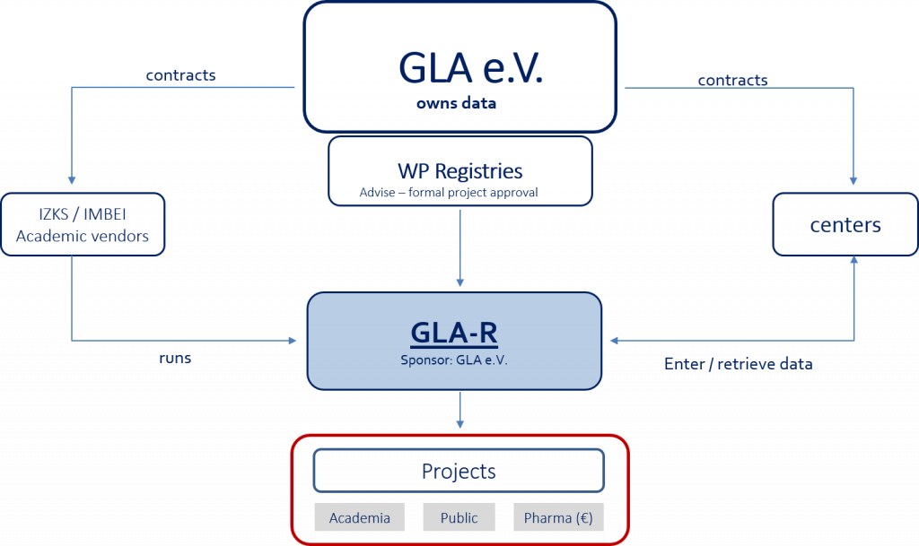

Estimated timeline (base case):
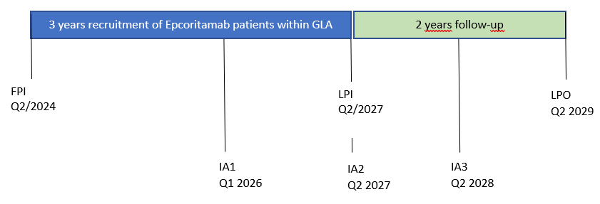
FPI: first patient in
LPI: last patient in
LPO: last patient out
IA: interim analysis

* Best case timeline: FPI in Q1/2024

Duration of Study Conduct Phases
Contract Execution to Study Start: | 6 months
Study Duration: | 5 years
End of Study to Publication: | 11 months after study completion until final publication; three interim analyses planned for the following milestones: 1) after at least 6 months follow-up after inclusion of 50 patients; 2) after at least 6 months follow up after inclusion of 100 patients; 3) after at least 12 months follow-up after inclusion of 120 patients

Planned Publication
Publication Type: (select all that apply) | ☒ Abstract ☒ Manuscript ☒ Poster
Publication Venue: | GLA will lead and plan publications.  Congress presentations / posters will be submitted to adequate congresses (e. g. EHA / ICML / DGHO / ASH). Journal will be selected by GLA.
Date to Submit to Target Publication: | Final analysis in Q1 2030

For Collaborative Interventional Studies Only
Product Requested: | N/A
Blinding Design: | None

